Alex Wuillaume

Card Sorting Write-Up

To complete the card sorting exercise I sorted the cards twice, and then asked two people to sort the cards with the link to the exercise. All of the sorting was done with the website Optimal Workshop. The sorts were conducted in an “Open” manner, so users were left on their own to create groups to sort the cards into.

After completing the card sort twice by myself, I started to get a better grasp of the different ways the website could be laid out from a UI and architectural standpoint. The cards started to fit into groups that more or less represented distinct webpages, all serving their own purposes.

Anything related to the staff of the site should be kept on its own page, and should not have too much relevance other parts of the site. Social media buttons could be integrated with each staff member, but the value of that does not seem to outweigh the cost of creating such a feature. Overall, a staff page is fairly low on the list of priorities, and is definitely not a primary focus. If it were created, it should be kept to pictures and short descriptions of everyone’s role.

When it comes to having a user account, there are some features it should allow to you have. Extra social media integration should be included, as I discovered after one sorting volunteer grouped social media buttons with user account creation. To entice people to create accounts, I believe that some options should only be available to those that have one, such as allergy settings and recipe-to-phone integration. These options would be seamlessly integrated into their respective places (recipe-to-phone on a page with a recipe) but only when logged in, otherwise have a “log in/register to send recipe to your phone!” Being able to rate recipes is another important feature that would be account-only accessible, as users will be drawn into the social aspect of creating food.

A major part of the site should be devoted to recipes, and being able to find the perfect one. Being able to sort by difficulty, ingredients, rating, cost, and any other factor someone creating a pizza could be limited to. Being able to find the perfect recipe is important, as it could lead the user to come back again for other ideas, or simply to look at how to recreate the pizza. Adding pictures, short embedded videos, and user submitted recipes would all allow a user to be able to explore a plethora of recipes to pinpoint exactly what they are looking for.

The recipe pages themselves need a good amount of depth also. Bad instructions can lead to someone never trusting the site again, and good ones leading a user explore more potential recipes. A user should be able to keep track of where they are when following the instructions, such as with check-mark boxes. Short instructional videos should be included with popular, high rated recipes, and an option for picture-aided instructions should also be added. Overall, the instructions and ingredient list themselves should not be cluttered, but should definitely be the draw and focus when on a recipe page. The difficulty will be incorporating the extras features without detracting from the simplicity that recipe instructions intuitively have.

Figure : First sort

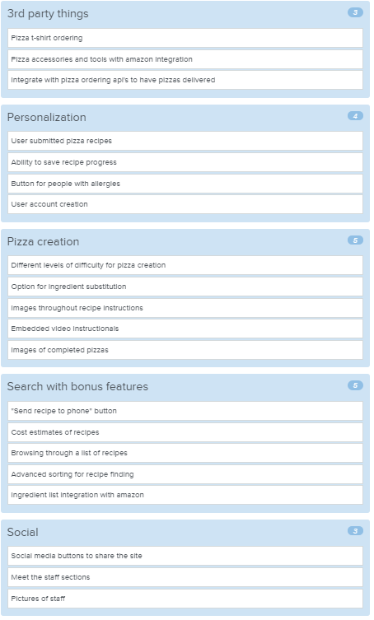

Figure : Second sort

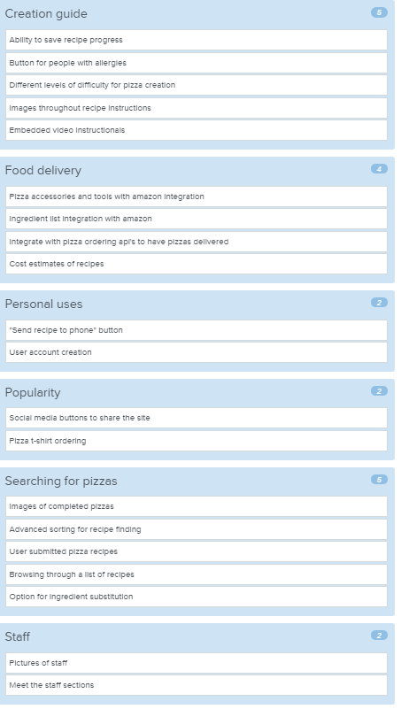

Figure : First volunteer sort

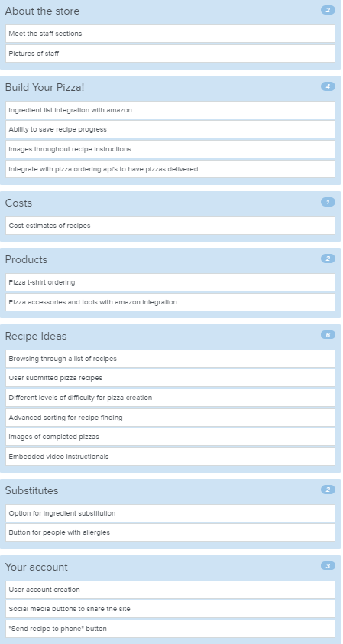

Figure : Second volunteer sort

